# Paradigms of Computer Programming - Fundamentals

## index

**Table of Contents**

Paradigms of Computer Programming - Fundamentals 1

index 1

Paradigms of Computer Programming 2

Introduction to the Mozart environment 4

The syntax of Oz 7

Functions and Numbers 7

Composition and recursion 8

Functional Programming 9

Invariant programming 11

Lists and pattern matching 15

The kernel language of the functional paradigm 17

Higher-Order Programming 18

Procedure values 20

Records 27

## Paradigms of Computer Programming

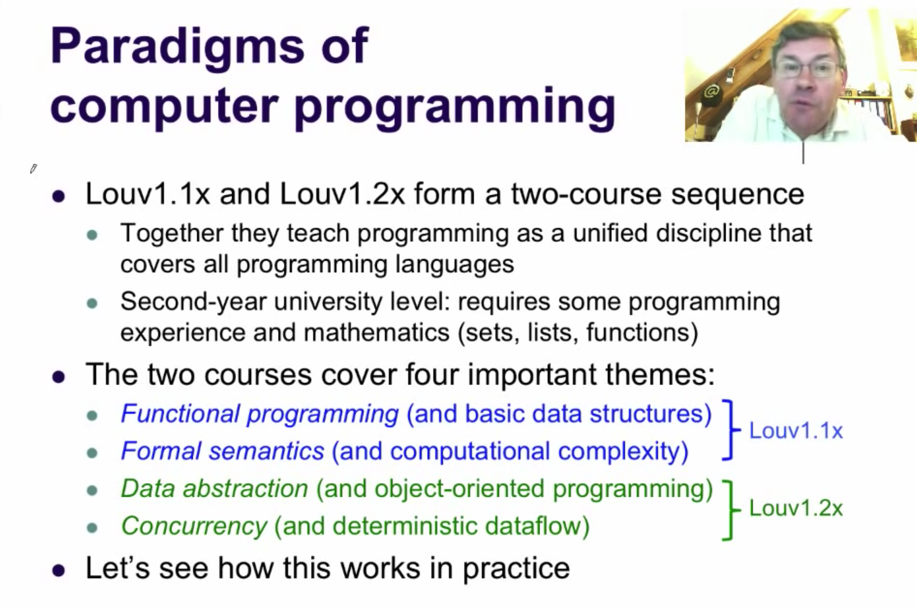

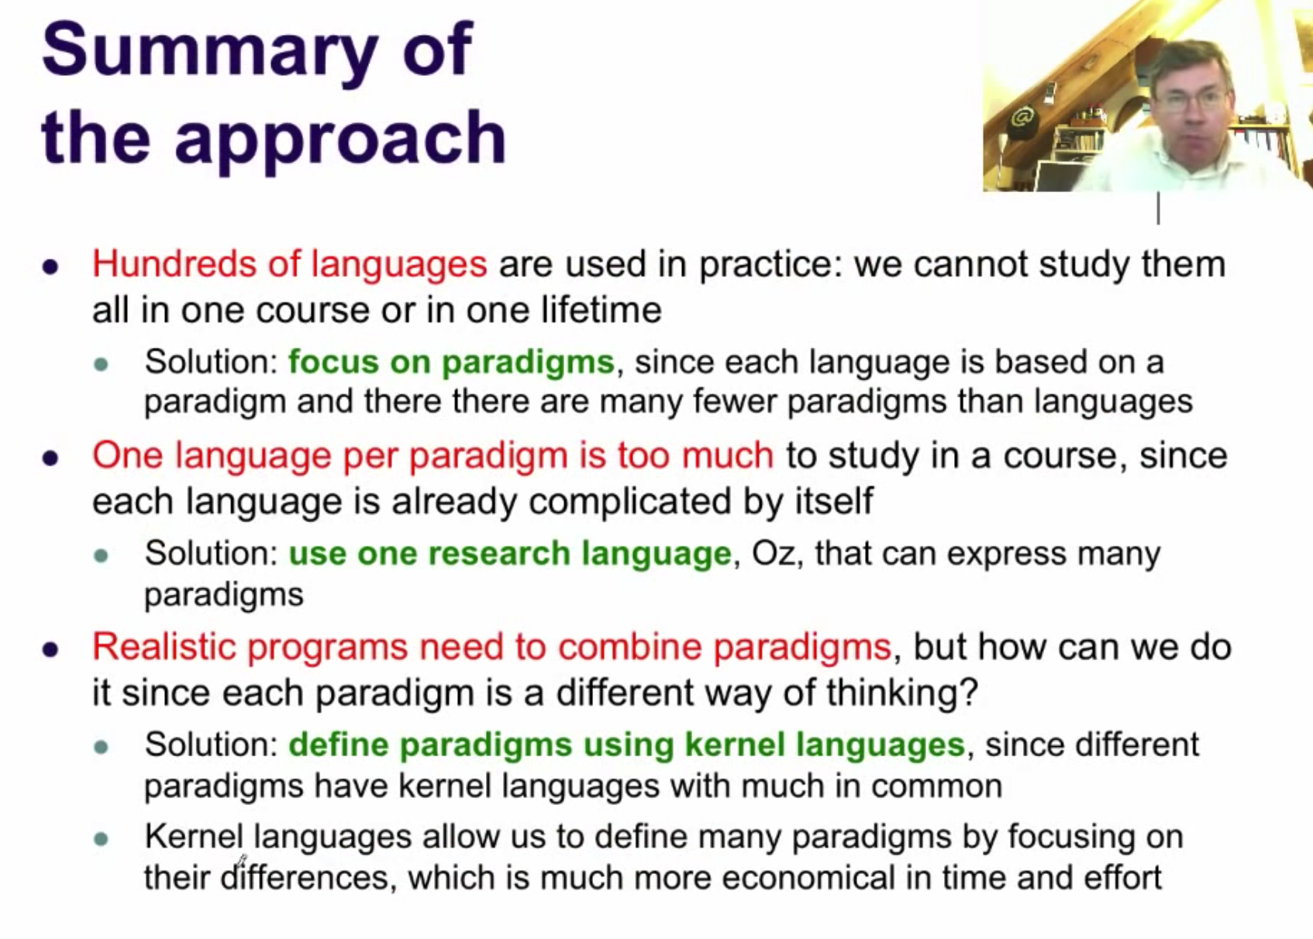

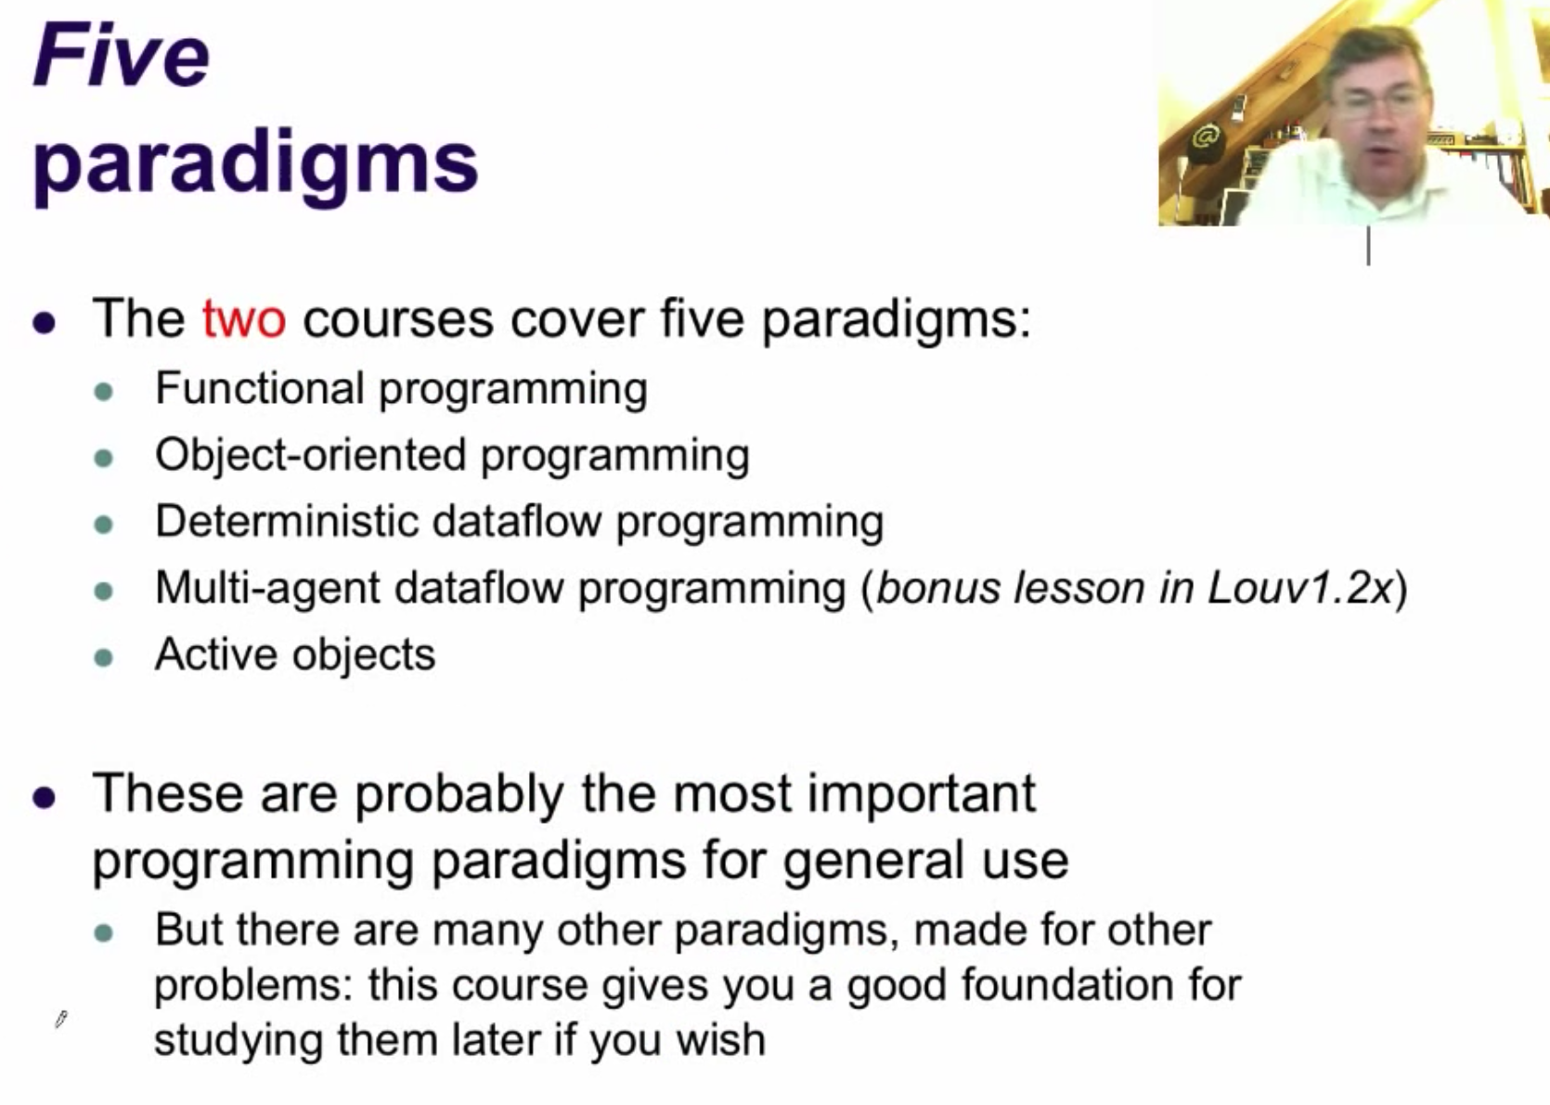

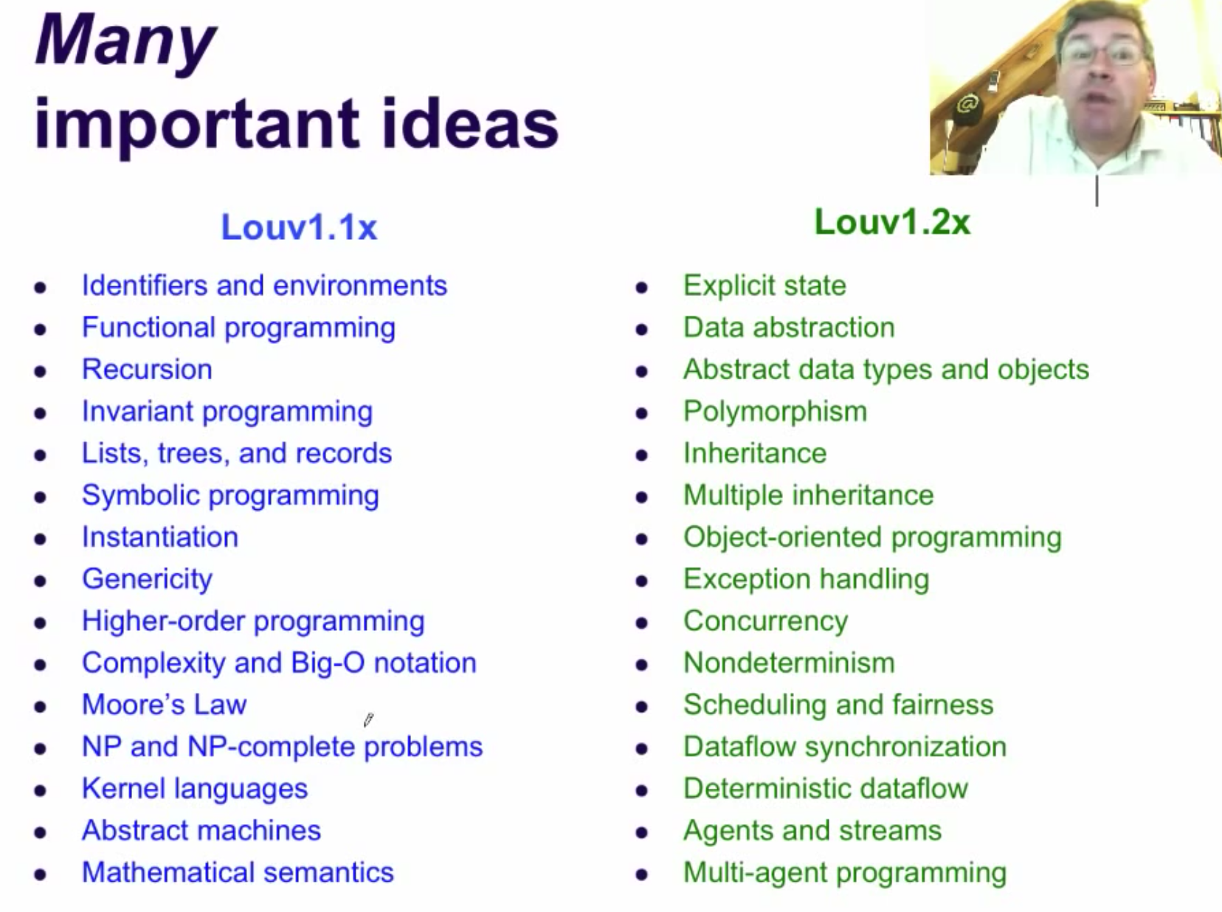

## Introduction to the Mozart environment

By default, the virtual image features a qwerty keyboard, because it's the one most of you probably use. If you want to change the keyboard layout however, you can do it using the command "setxkbmap". For example, go to Applications -> Sakura Terminal -> type**setxkbmap be**(for a Belgian azerty keyboard). To make this change permanent, you can launch automatically the command at the virtual machine's startup. To do so, edit $HOME/.profile.

The Mozart system has an interactive interface; it can be used as a kind of super powerful calculator. We show how this interface works, and we introduce three important concepts that underlie all modern programming languages:

The concept of *identifier*. An identifier is a character string that is used to reference entities during the execution of a program. In Oz, all identifiers must start with a capital letter. This is because of the language's multiparadigm nature: symbols that start with lowercase letters are used to represent data structures.

The concept of *variable in memory*. A program does its calculation in a part of the computer's memory. The memory is divided into variables, and each variable can be bound to the result of a calculation. In Oz, variables are single assignment: a variable can be bound to only one value. Any attempt to bind to another value is an error. This is because variables are a key part of functional programming. (Oz has other entities, called cells, that can be bound multiple times; we will introduce them later when we talk about object-oriented programming.)

The concept of *environment* (sometimes called a *frame*). The environment is the correspondence between the identifiers in the program and the variables in memory. At every point in a program's execution, there is a well-defined environment. More precisely, an environment is a function of one argument that takes an identifier and returns a variable in memory.

The declare statement is only usable in the interactive interface, since it creates a declaration that remains valid until the end of the interactive session. Inside programs, you need to use another instruction, the local statement, which creates declarations that are only valid over part of the program.

Variable declarations (using identifiers) using a local statement is presented in the following code:

**local Identifier1 Identifier2 /*... Other identifiers*/ in  
 % Your code here.  
end**

It's not possible to change the value of a variable! We say that variables are *single assignment*. Each variable can be assigned to only one value. Why are variables single assignment? It is because of the functional paradigm. A mathematical function is a fixed thing; it does not change once defined. Since variables are used to define functions, they have the same property.

Single assignment seems like a very big restriction. It *is* a big restriction! Making this restriction gives enormous advantages. It's like following a law. Why do we respect traffic rules? Because it gives enormous advantages. First, it greatly reduces the chance of having an accident. And this is true for single assignment as well. It reduces the chance of error. If we could assign more than once, we could assign a wrong value and break our program. Nothing would be certain; a program that is correct today could be broken tomorrow. In the functional program, a program that is correct today will still be correct tomorrow. The second advantage of following traffic rules is that it makes it easier to find our destination. We simply have to follow the signs. This is true for the functional paradigm as well: it makes it easier to write correct programs.

Now that we understand the motivation for single assignment, one question remains. How can we program if we are never allowed to change a variable's value? This is what we will see in the rest of this lesson and in the next lessons.

The **declare X** instruction makes the identifier X correspond to a variable *x* until the end of the session, or until the identifier is made to correspond with another variable. We can make X correspond with a new variable, let's call it *x'*, with another **declare X** instruction.

We can make the correspondence hold for a smaller part of the program by using the **local** instruction. **local X in <s> end** creates a new variable and makes X correspond to it within the instruction **<s>**. After the **end**, then X corresponds again to whatever it corresponded to before the **local** instruction.

During a program's execution, the same identifier can therefore correspond to different values, if it is redeclared to variables which are bound to different values. But this is not true for variables: the same variable can *never* be bound to different values! Remember the single assignment property: a variable can only be assigned to one value.

## The syntax of Oz

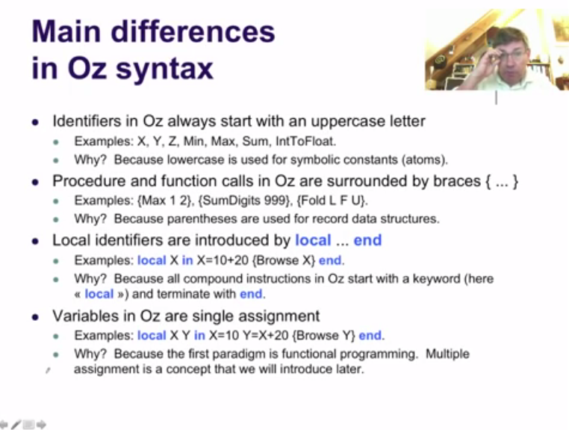

## Functions and Numbers

Functions are short-cuts for program code to execute, just as values are short-cuts for results of calculations. We would like to execute the same code many times, with possibly some values changed. The variables that hold these values won't change of course, but each time we execute the code we'll have new variables.

There are two kinds of numbers in Oz (and in most programming languages): integers and floating point numbers. Integers are exact, to any precision (limited only by available memory). Floating point numbers are approximations to real numbers, and are therefore rarely exact. There is no automatic conversion between the exact world and the approximate world in Oz. This is because we want to make all language operations explicit, to reduce the chance of making errors and to simplify reasoning about programs. There are two operations for moving between the two worlds: FloatToInt and IntToFloat. Each tries to find a number that is closest to its argument, in the other world.

## Composition and recursion

Now we have almost all the ideas we need to write real programs. There are just two more, which we will introduce now: functions that call other functions, and the conditional statement. The first is also called function composition. With this ability, we can build systems in layers, where one function calls another, and so on, to a very deep level. In current computing systems, this easily reaches to hundreds or thousands of levels. This is because a computing system consists of many software components and libraries that make up an operating system and an application.

Later on in the course we will exploit the ability to build in layers and extend it to make it more powerful. This leads to the concept of data abstraction. For example, object-oriented programming contains many useful techniques of data abstraction. But for now we will stay in the functional paradigm.

Look at the function SumDigits. It works for three-digit numbers. SumDigits6 works for six-digit numbers by calling SumDigits twice. Can we write one function that works for any number of digits (within the limits of the integer representation in the system)? Yes, this is possible using a powerful technique called *recursion*. A recursive function is one that calls itself.

Recursion seems to be like a circular argument. If the function calls itself, how can it ever stop? Actually, that's not hard. We just have to make sure that the function calls itself with a simpler argument each time. By *simpler* we mean an argument that needs less calculation. Eventually we end up with an argument that needs zero calculation, and the recursion stops.

To make the recursive function stop, we need to introduce a new instruction, the condition, or **if** statement. The statement **if <e> then <s1> else <s2> end** takes one expression **<e>** that must return a true or false result. If the result is true, then **<s1>** is executed. If the result is false, then **<s2>** is executed. The expression N==0 compares N with 0 and returns true if N is equal to zero and false otherwise.

The functional paradigm we have introduced so far, with the ability to define functions, to use function composition and recursion, and that has a conditional statement, is a complete programming language. We say it is *Turing complete*, which means that it can compute all the functions that a Turing machine can compute. Since a Turing machine is the most powerful computer we can build, this means that our language can compute anything that any other computer can compute. (The program might be long in some cases, but it is still possible to write it.)

## Functional Programming

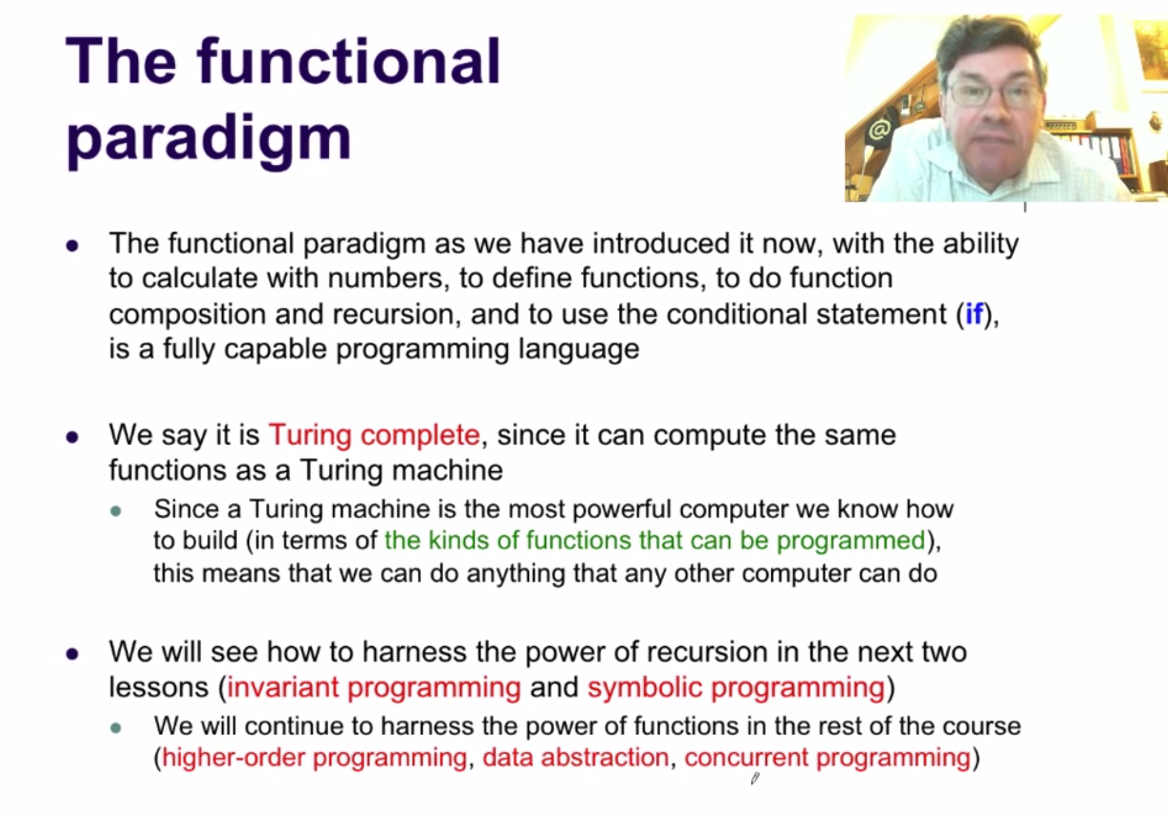

The first paradigm we will see in this course is functional programming. It is a special paradigm because it is one of the simplest useful paradigms, and this simplicity gives it unique strengths. We will use it as the base for all the other paradigms: each of the two other paradigms we will see in this course adds a single concept to functional programming.

Functional programming is usually considered a form of declarative programming. To explain what this means, we need to distinguish two meanings of the term declarative programming: a long-term one and a short-term one.

Declarative programming in the long term is a vision for computer programming: the programmer should say only what he or she wants, and the computer should figure out how to calculate it. The history of computer programming is a long, slow climb toward more declarative programming. Declarative programming in the short term is the use of mathematics in programming. Two important paradigms based on this idea are functional programming and logic programming. Historically, these two paradigms were considered to be closer to the long-term vision than other paradigms. This connection between the short term and long term views has lost much of its force today, but tradition has kept it largely unchanged.

Functional programming has one key property: a function never changes its behaviour. A function in this paradigm is a function in the mathematical sense, like "x squared". The property that functions never change is both the strength and weakness of functional programming. The strength because it means that working programs cannot be broken. The weakness because it means that programs cannot change to meet changing demands. The only way to change a program is to create a new program. Functional programming, because of this key property, is an important paradigm and it is important to learn how to think in it.

Variables in functional programming are like mathematical variables, and they can only be assigned to one value. Multiple assignment doesn’t work here.

## Invariant programming

In the previous lesson we saw a simple example of a recursive function, namely SumDigitsR. This function is able to calculate the sum of all digits of any integer, no matter how many digits it has (within the limits of the system's representation). The recursive call and the conditional together are similar to a *while loop*: an execution that is repeated while some condition is satisfied (like N==0). Each function call does one iteration of the loop.

In this lesson we will go to the root of this intuition. We will understand in a deep way the connection between recursion and loops, and we will see how to write correct and efficient programs that use recursion. We will see that **a recursive function is exactly the same as a while loop, if one essential condition is satisfied: if the single recursive call that is executed is the last operation done by the function (this is called *tail recursion*).** *To write a tail recursive function, we need to introduce one or more extra arguments*, to help calculate the result. An *accumulator* is an extra argument in which the result is calculated piece by piece (it is accumulated).

We will give a technique, called ***invariant programming***, to program correct and efficient loops. This technique applies both to the functional paradigm and to the imperative paradigm. (An imperative paradigm allows variables to be assigned more than once; many widely used languages, such as Java and C++, are based on imperative paradigms.) As part of this technique, **we define** **two formal concepts, the *specification* of a function (a mathematical formula that defines what the function calculates) and the *invariant* of a recursive function (a mathematical formula that is true at each recursive call).** The right way to program a function is to start with the specification. The right way to program a loop (a recursive function or while loop) is by starting with the invariant.

The sum of digits function we did in the last lesson seems to be very natural, so natural that it's hard to imagine another way! But this intuition is wrong. There is a second approach to write the function, quite different that leads to another, and better definition. To introduce this approach, let's start with a simpler function, namely factorial. This will let us focus on the key insight. Afterwards, we will come back to sum of digits.

We first give the specification of the factorial function, a mathematical formula that defines it. Our first implementation of factorial follows exactly this specification. This definition is in the same style as the sum of digits function. It is fine from a mathematical point of view, but quite bad from a programming language point of view.

The second implementation uses an approach called the principle of communicating vases. We start with a formula that separates the factorial into two parts: *n!=i!*a*. We know *n* but we don't know *n!* (yet). The other variables, *i* and *a*, are introduced together. Initially, *i=n* and *a=1*, so the formula holds. Now, we come to the key insight: we will change *i* and *a* *together*, in such a way that the formula still holds. If we can arrive at a point where *i=0*, then *a* is equal to *n!*, the answer.

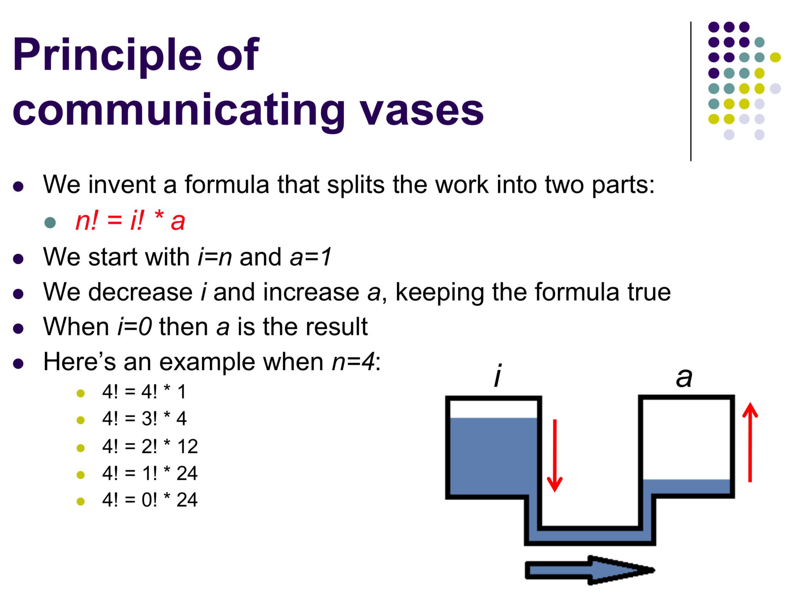

For factorial, we will decrease *i* and increase *a* together. We will decrease *i* by *1* and increase *a* by multiplying it by *i*. By doing this, the formula remains true. We can easily show this rigorously: *i!*a = i*(i-1)!*a = (i-1)! * (i*a)*. Let *i'=i-1* and *a'=i*a*. Then the last expression is equal to *i'!*a'*, which is exactly our formula. Now we can write the second implementation.

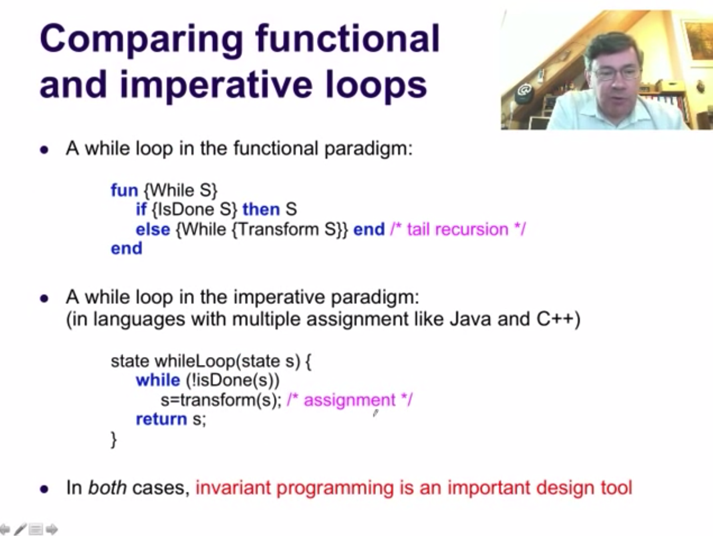

Example with the power function:

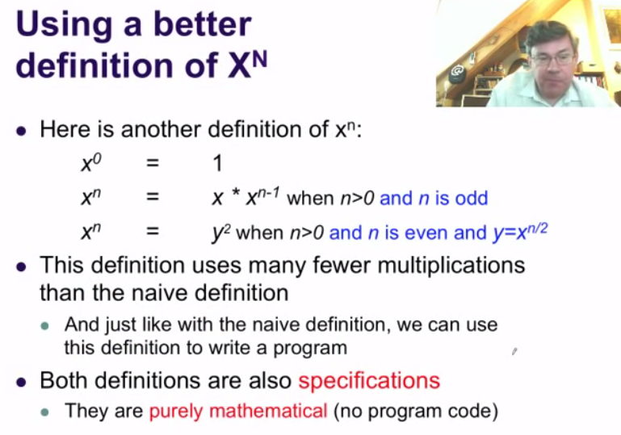

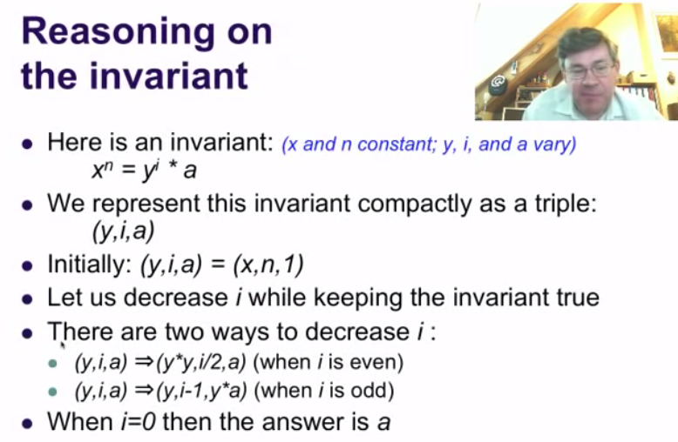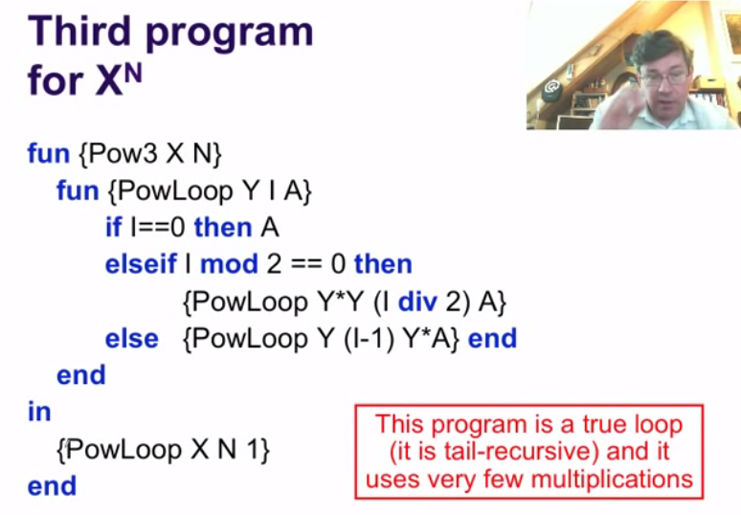

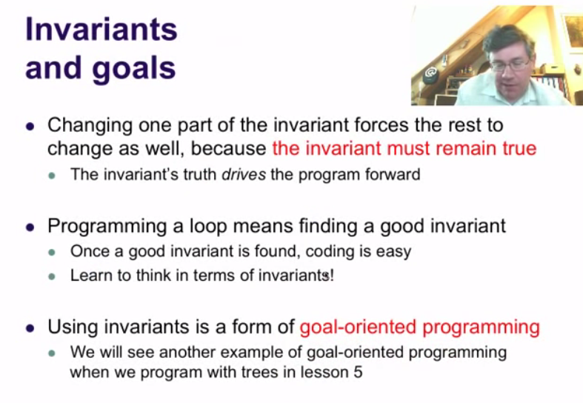

## Lists and pattern matching

In the last lesson we learned how to program recursive functions that calculate with integers. We learned how to use invariant programming to make these functions efficient, so they are exactly loops. But integers are a rather simple data type. We would like to make calculations with many integers at a time. We would like to write functions that calculate with large amounts of data. For this, we need a new idea: we need to define a compound data type that combines many other data type values together, into a single compound value.

One of the first, and most useful, compound data types that was invented is the list. A*list*is an ordered collection of elements. Lists are a fundamental data type in the symbolic language Lisp (which stands for List Processor), invented in the 1950s. A*symbolic language*is a language that has special support to calculate with data that are not numbers, for example, lists, trees, graphs, and other nonnumeric data.

We can use lists in Oz. The simplest way to create a list is with brackets [ ... ]. For example, X=[1 2 3] is a list of three elements, 1, 2, and 3. We can calculate with lists and display lists with Browse. The call {Append X X} will calculate and return a new list consisting of the elements of its first argument (here X) followed by the elements of its second argument (again X). This call will return [1 2 3 1 2 3].

Note that lists, once created, cannot be changed. Lists are*values*, i.e., they are*constants*. This is a consequence of programming in the functional paradigm. If we need a different list, we cannot change an existing list, instead we must create a new list.

We can give a precise definition of a list using recursion. A list is either an empty list (denoted as 'nil' without the quotes) or a pair of an element and another list (both separated by '|' without the quotes). The word 'list' appears both in the head and in the body of this definition. This definition is not circular because the list in the body will always be smaller than the list in the head. We define a list in terms of a smaller list, and so forth, until we define the empty list. This is the same idea that recursive functions use to avoid infinite executions. Here, the idea avoids data structures of infinite size.

We give a precise definition of a list using a formal grammar. The particular grammar we use is an example of EBNF: Extended Backus Naur Form. This is named after John Backus and Peter Naur, two pioneers of programming languages. EBNF is one of the most popular ways of defining the syntax of programming languages. In EBNF, a grammar definition consists of grammar rules. Each grammar rule defines the syntax of one language entity, such as <List T>. The details of the meaning of the rules are explained in the video. One important point is not to confuse the two symbols | and '|'. The former is part of EBNF's own syntax; it means "or". The latter is part of the language entity that we are defining; it means "|" (a vertical bar by itself, with no symbols surrounding it). In the notation <List T>, the T is called a type variable. This should not be confused with identifiers and variables in memory. Type variables exist only in grammar rules, not in programs.

A major subtlety in grammar definitions is not to confuse a thing with its representation. We use the famous painting "Ceci n'est pas une pipe" ("This is not a pipe") by the surrealist painter René Magritte to illustrate this point.

We present two useful representations of lists: syntactic sugar and a graphical representation. The notation [10 11 12] is just another way to write 10 | 11 | 12 | nil. Both notations represent exactly the same list. For the programming system, there is no difference. The first notation exists only as a facility for the programmer. We call it a syntactic sugar.

A list has a natural graphical representation as a binary tree. A tree is a kind of graph, i.e., a figure consisting of nodes, which are geometric points, connected by edges, which are (curved) lines. Formally, a graph is a set of nodes and edges, where an edge is a pair of two nodes.

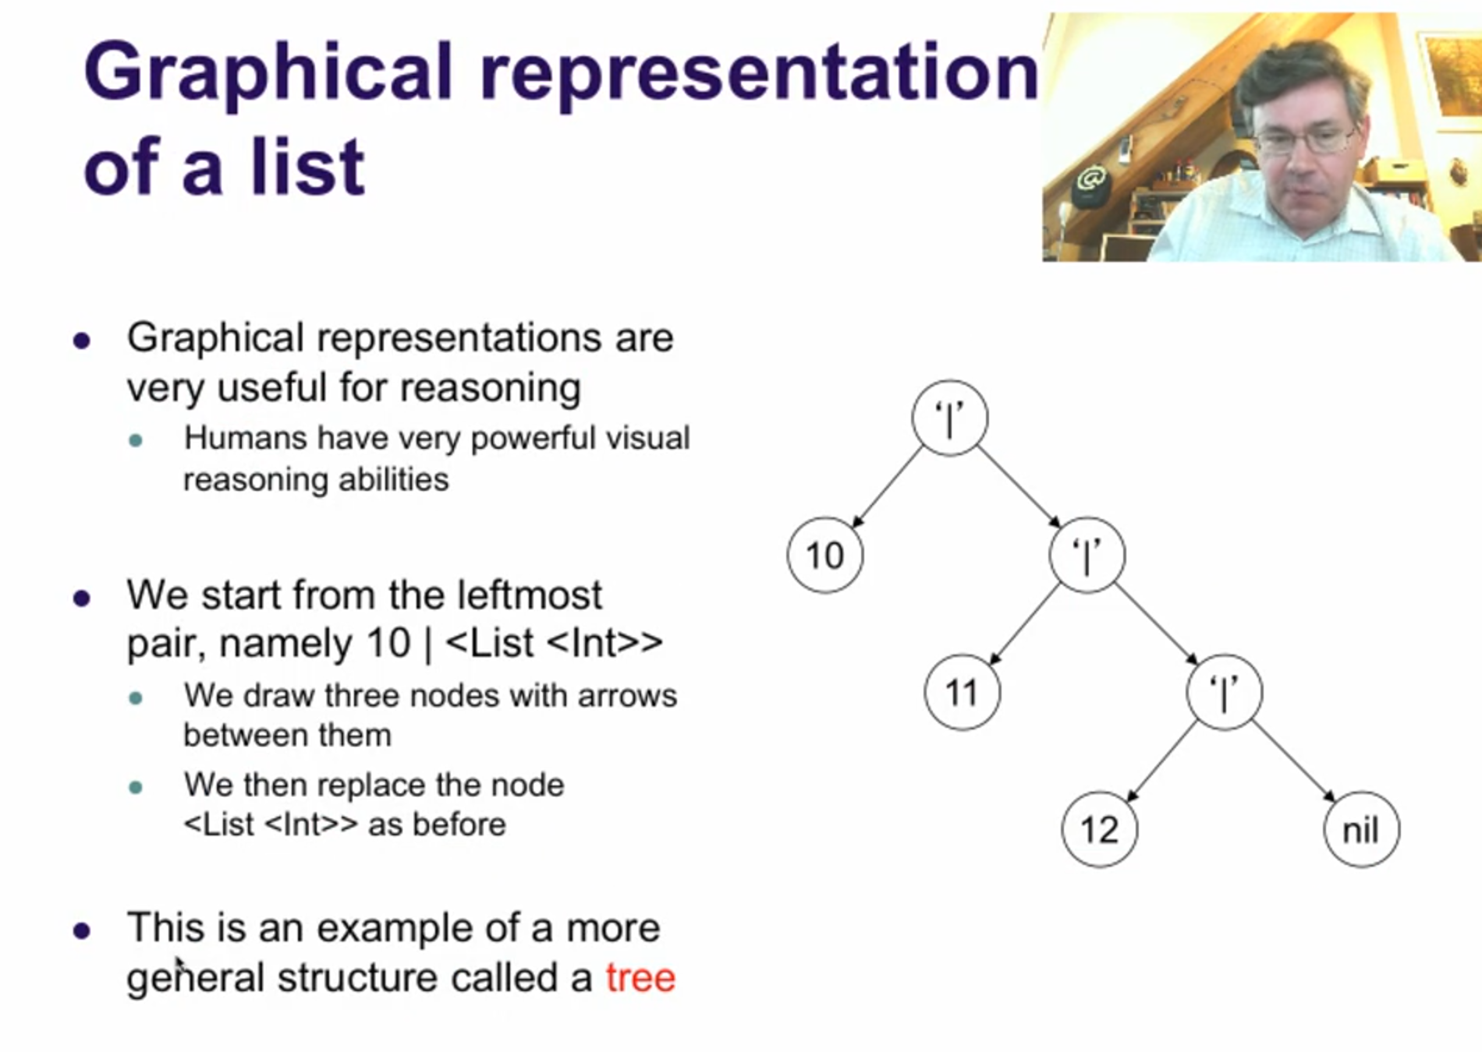

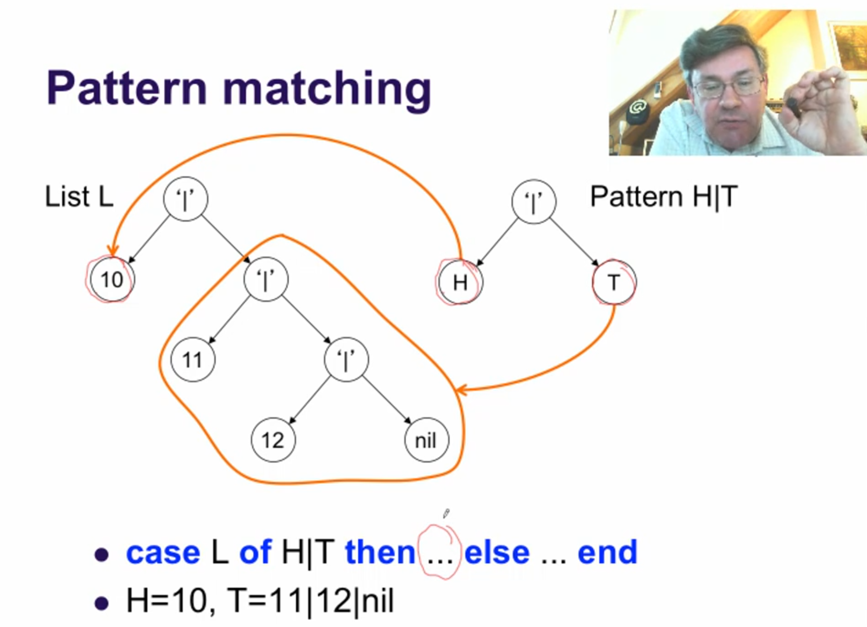

## The kernel language of the functional paradigm

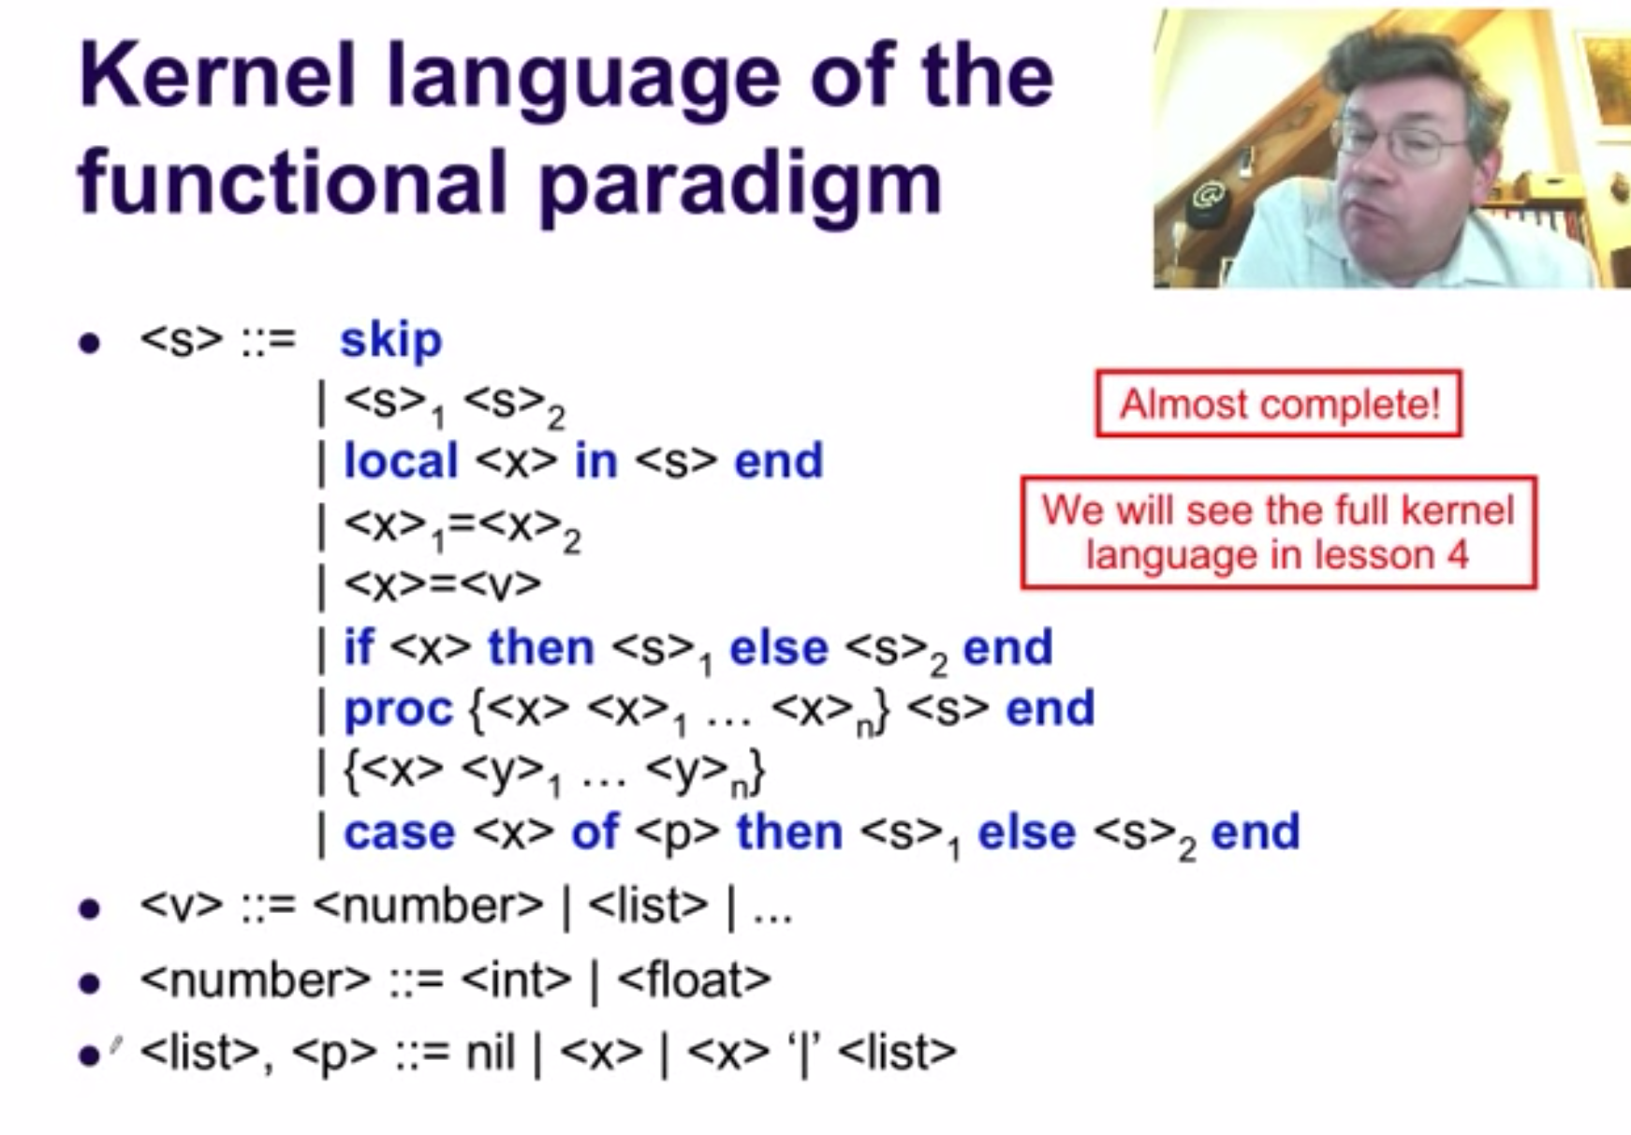

## Higher-Order Programming

What is displayed by the following example:  
  
**local**P Q**in**  
**proc**{P} {Browse 100}**end**  
**proc**{Q} {P}**end**  
**local**P**in**  
**proc**{P} {Browse 200}**end**  
 {Q}  
**end**  
**end**

Does this example display 100 or 200? If you think that 100 is displayed, then you are right! We can explain this because of static scope. Look at the P inside of Q's definition. What is its scope? It starts from the first**local**up to the final**end**(leaving out the inner**local**-**end**). In this scope, we look for the definition of P. It is the first procedure, which displays 100. So the P inside of Q uses this definition. It does not matter that it is inside a procedure; the scope rules are the same. When we call Q, the fact that there is another procedure named P in the environment has absolutely no effect on the execution of Q.

How does Q know that it has to call the first definition of P? It is because the procedure Q is stored in memory together with a reference to the first definition of P. This reference is stored in a data structure called the*contextualenvironment*. The contextual environment is stored together with the code of Q.









### Procedure values

Now that we know about the contextual environment, we can understand exactly what a procedure is and how it is stored in memory. A procedure is a*value*, just like any data item in memory is a value. The procedure name (the identifier) is just a reference to this value, exactly like the N in the instruction N=42. The identifier N is just a reference to the value 42 in memory. To see this up close for a procedure, let's look at an example:

**proc**{Inc X Y} Y=X+A**end**

This procedure declaration is actually defining a value in memory. The name Inc is bound to the value. So the procedure declaration is actually something like this:

Inc =*(some value)*

What is*(some value)*? It is exactly the procedure we wrote before, but without the identifier Inc, which is not part of the procedure's definition in memory. We write it as follows:

Inc =**proc**{$ X Y} Y=X+A**end**

This looks very similar to the procedure definition above, except for the symbol '$' that replaces the identifier Inc. We insert this symbol as a placeholder. Instead of just removing the Inc and replacing it by nothing, we replace it by a new symbol that cannot be confused with an identifier. (If we were to remove it, X would sit in the place usually used for the procedure name, which is confusing since X is an argument.) The symbol '$' is a reserved symbol in Oz that is used as a placeholder for an identifier, to avoid confusion with an identifier.

So the Inc in the previous declaration is bound to a procedure definition in memory. It has the procedure's code and it also has the contextual environment. So a procedure value in memory is a pair; it has two parts. It looks like this:

*i*= (**proc**{$ X Y} Y=X+A**end**,{A→*a*})

where*i*is the variable that Inc refers to. This pair is called a*procedure value*. It is also called a*closure*, or even a*lexically scoped closure*(because the language has lexical scoping, which is just another name for static scoping). Procedure values can be used just like any other value, such as numbers or lists. They can be stored inside of compound data structures, passed as inputs to procedures or functions, and returned as outputs from procedures and functions (for procedures, being an output means that you pass an unbound variable as argument, which is bound inside the procedure).





Procedures have two important properties: they are values and they have a contextual environment. The combination of these two properties leads to very powerful programming techniques. In fact, we can say that the whole layered construction of data abstractions that gives today's programming systems so much power is based on procedures with these two properties! So the procedure concept, as defined here, is one of the most important concepts in all of computer programming. We will see a lot of this power during the rest of the course, but let us see a little bit of the power right now. We can pass a procedure to another procedure as input or output. This ability is called*higher-order programming*. The*order*of a procedure is a positive integer that we define recursively. The order of a procedure is 1 is none of its arguments are procedures or contain procedures (they might be numbers or lists of numbers). Otherwise, the order is 1 plus the highest order of any argument (input or output).

Here's an example of a function passed as an input (which is called genericity):

**fun**{Map F L}**case**L**of**nil**then**nil**[]**H|T**then**{F H}|{Map F T}**endend**

Recall that this function is tail-recursive, since the compiler puts the recursive call to Map after the list construction. Here's an example call:

{Browse {Map**fun**{$ X} X*X**end**[7 8 9]}}

What does this display? By the way, what is the order of Map?

Here's an example of a function passed as an output (which is called instantiation):

**fun**{MakeAdd A}**fun**{$ X} X+A**endend**

We can call it as follows:

Add5={MakeAdd 5}  
{Browse {Add5 10}}

What is the order of MakeAdd? What is the contextual environment of MakeAdd? It is the empty set. What is the contextual environment of the function that is returned by MakeAdd? It is {A→*a*} where A is the argument of the enclosing MakeAdd call.

Here's an example of a function that takes a function as input and returns a function as output:

**fun**{Compose F G}**fun**{$ X} {F {G X}}**endend**

This takes two one-argument functions and returns a new function which is their composition. Here's an example call:

Fnew={Compose**fun**{$ X} X*X**endfun**{$ X} X*X*X**end**}

What does Fnew calculate? What is the contextual environment of Compose? What is the contextual environment of the function that is returned by Compose? What is the order of Compose (assume that F and G are first-order)?



La siguiente función







En la siguiente función, L es una lista, F es una función, y U es un acumulador:







### Records

Now that we've explained procedures, let's look again at data types. We have seen integers, floating point numbers, and lists. So far, lists are the only compound data type we have seen. The kernel language supports a much more general compound data type called a record. A list is just a special kind of record. A*record*groups together a set of values into a single compound value. Each value is indexed by an integer or a symbol called an atom. An*atom*is a sequence of letters or numbers that starts with a lowercase character. Atoms are symbolic constants that are very useful for symbolic calculations. All symbolic languages (such as Lisp, Scheme, Haskell, Erlang, Prolog, and so forth) support atoms. Let's compare lists and records. Here is a list:

L=[john paul george ringo]

This list has four atoms, namely john, paul, george, and ringo. Atoms can be used in calculations just like any other value. For example:

{Browse L.1}

displays john (the first element of L), and:

{Browse L.2.2.1}

displays george (the third element of L). Here is a record:

R=rectangle(bottom:10 left:20 top:100 right:110)

This record groups together four integers. The atom 'rectangle' just before the left parenthesis is called the*label*of the record. The atoms bottom, left, top, and right are called the*field names*, or*features*, of the record. The four values 10, 20, 100, and 110 are stored in the*fields*of the record. They can be accessed with the*dot operation*:

{Browse R.bottom}

displays 10. The dot operation is used in similar fashion as for lists. This shows that the field names for a list are 1 and 2. The list a|nil is actually a short-hand for '|'(1:a 2:nil). So our original definition of lists is already a syntactic sugar.*Lists are not primitive values*, they are defined in terms of records.

Records are the only compound data type in the kernel language. They are very general, and we will use them to build many other compound types. We have used them to define lists. We will use them later in the course to define trees. There are many operations defined in Mozart to calculate with records. We can use records in a**case**statement (we will see a big example of that in the next lesson). We can call built-in operations on records, such as the Width, Arity, and Label functions.